# Open Source 3D Annotation tool for Lidar Data and Imaging

Scope:

To create a 3D annotation tool capable of accurately building datasets which will serve as a base to train future 3D detection technology.

Technology Stack:

* Lidar Data ( [Velodyne HDL-64E](http://wiki.ros.org/velodyne/Tutorials/Getting%20Started%20with%20the%20HDL-64E) ) {Compatible with any point cloud data also(.ply, .pcd)}
* Python 2.7.x (ROS), Python3.5.x (Application), C++ (Processing)
* ROS Kinetic
* OS Support (Windows, Ubuntu)
* Libraries (PCD, Open3D, PySimpleGUI, Numpy, OS, TensorFlow, MatPlotLib)

Methodology:

The easiest and generally quickest way to run 3D annotation is to Provide the user with options and to let them choose which ones they wish to keep and the ones they choose to discard.

Providing a dual option (Point-cloud to Image and vice versa) in helps in better visualization from the annotator’s perspective allowing them to work with whichever frame they are comfortable with or is more intuitive.

Steps:

Progress Made:

Our System is capable of annotating and translating the 3D points from both Pointcloud to image and vice versa and stores these in a JSON file for pcd data and text file for the respective imaging data.

GUI allows for easy access to the data and file handling allowing rookie users to easily utilize the resources.

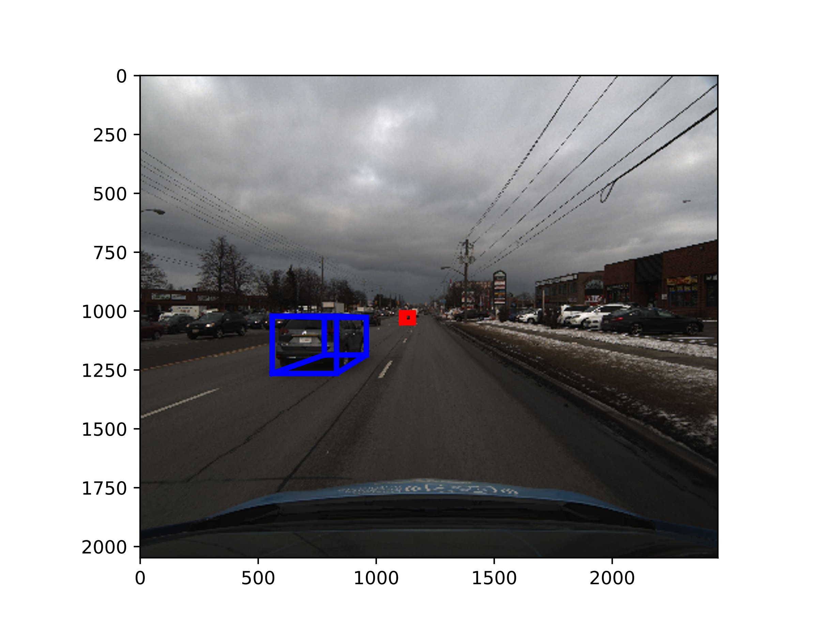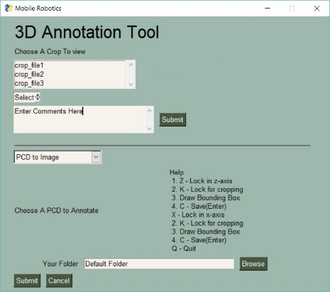 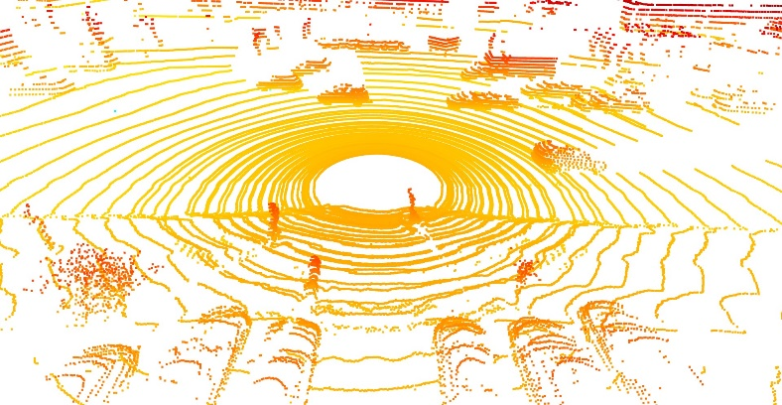

Conclusion:

The automatic cropping option almost halves the time of annotating the frames.

The tool is OpenSource and under constant development available at

Primarily for vehicle detection but can be used for any 3D data set pairs or can be modified to only annotate in pointcloud or image data in case missing on of the pair.